AutoEmail IgnoreSessionStatus Tests
Tester: Tony Tasker
Date: 7th February 2017
Time: 15:30
PC/Server: TonyTasker-PC
Database: Simmons_V7_Test (Copy of live Simmons and Simmons DB)
Works Summary: N/A
Works Order: N/A
Task: N/A
Notes: These tests were performed using CABS Console (7.0.0.27), Microsoft SQL Server Management Studio. Output to the Results and Messages Output Windows are used to determine the success of the tests. Also the receipt of emails.

Testing implementation of configuration switch IgnoreSessionStatus which, when set, all functions in a session, are treated as discrete individual bookings.

Pre-Test Setup
No | Task | Tester | Pass | Notes
1 | In X CABS Config, Section  Set DebugFlag=1  In section CABS_AUTO_EMAIL_FUNCS_Trigger  Set DebugFlag=1 | TT
2 | In X CABS Config, Section AEFCON change setting  Frequency=D:1;H:0;M:0;W:1;S:0;T:0730;L:B4;  to  FFrequency=D:1;H:0;M:0;W:1;S:0;T:0730;L:B4;  Add  Frequency=D:0;H:0;M:1;W:1;L:CR; | TT |  | Changing Key name from Frequency to FFrequency keeps the original setting visible but enables a betting setting to be used for testing purposes.
3 | In X CABS Config, Section AEFCON change settings to those indicated below:  EnabledB=I:1;U:1;D:0  EnabledC=I:1;U:1;D:0 | TT

Post-Test Setup
No | Task | Tester | Pass | Notes
1 | Reverse any Config Changes in X CABS Config | TT

Tests

Test Simmons and Simmons Configuration Script
No | Test | Tester | Pass | Notes
1 | In CABS Console, locate the AEFCON settings and delete the line IgnoreSessionStatus=1 (if it exists) | TT |  | There is an issue with data in the MBRFILE table such that MBR_IMPKEY is not unique.
2 | Run script Simmons and Simmons Configuration.sql | TT
3 | In CABS Console ensure:  IgnoreSessionStatus=1  is added to section AEFCON | TT |  | Ensure IgnoreSessionStatus is added to configuration of AEFCON as per Figures below.

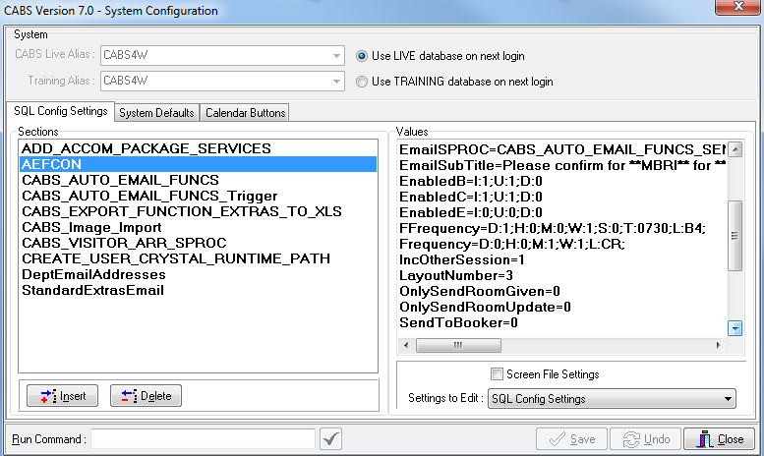
Figure 1 – AEFCON Setting Before Configuration Script Run

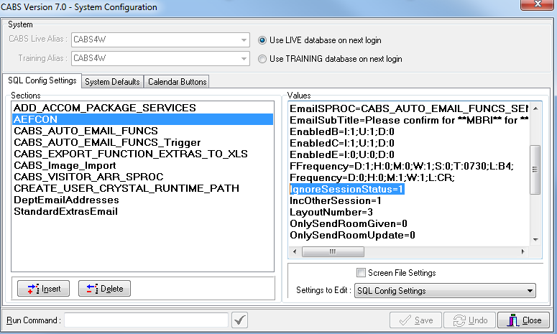
Figure 2 - AEFCON Setting After Configuration Script Run

Ensure Two Functions in a Session Send AutoEmail (AEFCON) Correctly

No | Test | Tester | Pass | Notes
1 | In CABS Console, open the booking diary.  Select an appropriate date to add Function Bookings.  Selected 9th February and copied F654924 to a later time  Booker used: Mrs Tracey Trevallion (M072853)  Changed Status to PROVNL  Booked Room  Chose MBR M077711 (Bob Jones)  Function was F680416.  Added Extra “Tea, Coffee, Biscuits” (11 Covers) | TT
2 | Copied Function F680416 to additional room  Included the Booking in a Session.  New Function F68017 was created.  Session Number was S021033. | TT
3 | In SSMS run query:  SELECT * FROM vw_AEFLink  To check the AutoEmail queue | TT |  | For Email Template AEFCON:  AEFL_CanSend should be 1,  AEFL_Sent should be 0,  SessionSendable should be 1,  Sendable should be 1,  MatchCriteria should be 1  for AEFL_FREF F680416 and F680417.
4 | Process the AutoEmail  EXEC CABS_AUTO_EMAIL_FUNCS_SESS_CHECK | TT |  | Emails delivered as per Figures 3 and 4

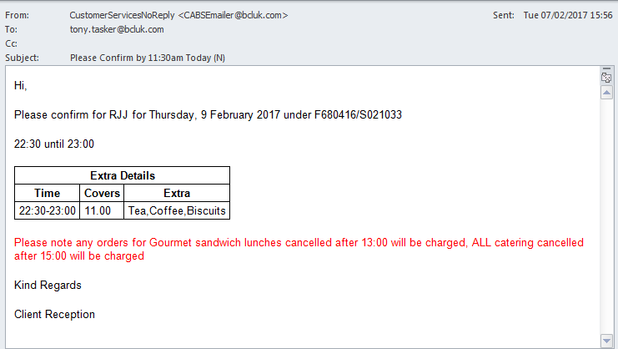
Figure 3 – 1st Confirmation Email Sent (AEFCON)

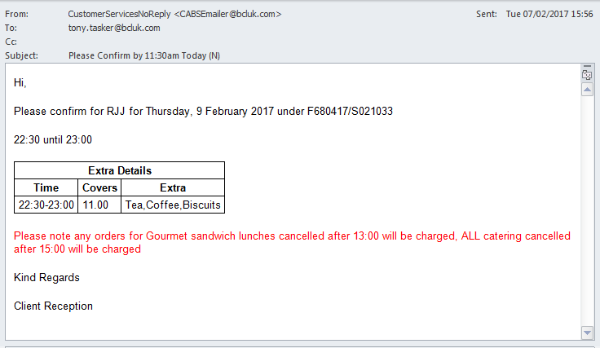
Figure 4 - 2nd Confirmation Email Sent (AEFCON)

Ensure Two Functions in a Session Only Send One AutoEmail (AEFCON)

No | Test | Tester | Pass | Notes
1 | In CABS Console, open the booking diary and CANCEL the previously created Functions.  In Section AEFCON in System Defaults set  IgnoreSessionStatus = 0  Copy F654924 to a later time  Booker used: Mrs Tracey Trevallion (M072853)  Changed Status to PROVNL  Booked Room  Chose MBR M077711 (Bob Jones)  Function was F680418.  Added Extra “Tea, Coffee, Biscuits” (7 Covers) | TT
2 | Copied Function F680418 to additional room  Included the Booking in a Session.  New Function F68019 was created.  Session Number was S021034. | TT
3 | In SSMS run query:  SELECT * FROM vw_AEFLink  To check the AutoEmail queue | TT |  | For Email Template AEFCON:  AEFL_CanSend should be 1,  AEFL_Sent should be 0,  SessionSendable should be 1,  Sendable should be 1,  MatchCriteria should be 1  for AEFL_FREF F680418 and not for F680419.
4 | Process the AutoEmail  EXEC CABS_AUTO_EMAIL_FUNCS_SESS_CHECK | TT |  | Email delivered as per Figures 5

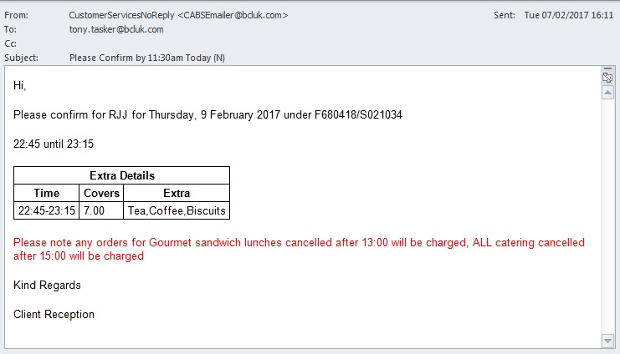
Figure 5 - Only 1st Confirmation Email Sent (AEFCON)

Ensure a Single Function Booking Results in AutoEmail (AEFCON) Sent

No | Test | Tester | Pass | Notes
1 | In CABS Console, open the booking diary and CANCEL the previously created Functions.  In Section AEFCON in System Defaults set  IgnoreSessionStatus = 1  Copy F654924 to a later time  Booker used: Mrs Tracey Trevallion (M072853)  Changed Status to PROVNL  Booked Room  Chose MBR M077711 (Bob Jones)  Function was F680424.  Added Extra “Tea, Coffee, Biscuits” (9 Covers) | TT
2 | In SSMS run query:  SELECT * FROM vw_AEFLink  To check the AutoEmail queue | TT |  | For Email Template AEFCON:  AEFL_CanSend should be 1,  AEFL_Sent should be 0,  SessionSendable should be 1,  Sendable should be 1,  MatchCriteria should be 1  for AEFL_FREF F680424.
4 | Process the AutoEmail  EXEC CABS_AUTO_EMAIL_FUNCS_SESS_CHECK | TT |  | Email delivered as per Figures 6  Note: No Session number displayed.

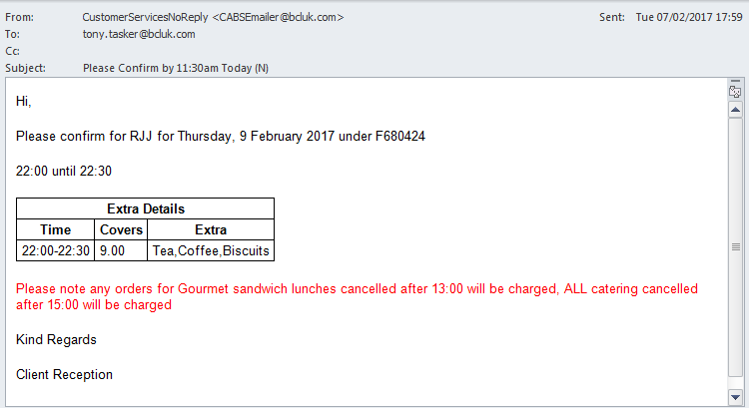
Figure 6 - AutoEmail (AEFCON) Sent for a SIngle Function Booking

